## Preliminary Design for Robot Racing 2009

The goal of this project is to design an autonomous vehicle with the primary objective to become a platform for intelligent robotics experiments and a secondary objective of participating in the robot racing competition (http://www.eng.uwaterloo.ca/~rracing/). As of now the robot is to be designed for optimal performance at the aforementioned competition.

A summary of the competition requirements are as follows. The robot has to:

* follow a figure-8 circuit as outlined by orange pylons
* follow road signs and traffic lights (two stop signs and one set of traffic lights at the start position)
* take part in a straightaway drag race

Also note that white lines on the road are located wherever there are stop signs on the road.

With the above mentioned requirements, the robot was designed to have the following sensors:

* CMU Camera for blob detection of traffic signs and lights
* Ultrasonic rangefinders for pylon and obstacle detection
* IR Proximity Sensors for short range obstacle detection
* GPS for macro-localization

There is a possibility of adding some line followers as a way of confirming the traffic signs, however this will be added after the current design implementation is completed.

With research it was found that the best ultrasonic range finders used I2C for communication and the robot design would require multiple range finders for better localization on the pathway. This implies that an I2C bus be constructed. However, it was decided that handling the I2C bus, serial interfacing and analog interfacing would be hard for a microcontroller to do especially because it would be conducting a fair amount of computation heavy processes to control the robot. With this in mind a secondary microcontroller was added to handle the I2C bus and analog interfacing, while the primary microcontroller will process the sensors with serial interfaces, conduct the necessary computations based on all the sensor readings and control the robot actuators.

The above design is laid out in Figure 1. For the mechanical platform a remote control vehicle was dismantled, and its motor control system stripped out.

An itemized list of parts is shown in Table 1

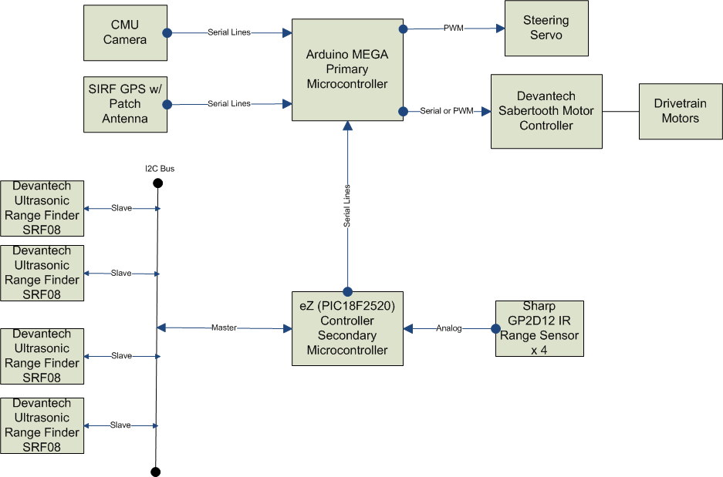

Figure 1 : Design Layout

Table 1 : Itemized List of Parts

|  |  |  |
| --- | --- | --- |
| **Item** | **Details** | **Cost** |
| CMU Camera (v2) | <http://www.cs.cmu.edu/~cmucam2/> | $200 |
| SIRF GPS w/ Patch Antenna | <http://www.usglobalsat.com/p-46-em-406a-sirf-iii.aspx> | $80.84 |
| Devantech Ultrasonic Range Finders x 4 | <http://www.robot-electronics.co.uk/htm/srf08tech.html> | $72.64 x 4 |
| Sharp GP2D12 IR Range Sensor  X3 | [http://www.robotshop.ca/sharp-gp2d12-ir-range-sensor-10-cm-80- 1.html](http://www.robotshop.ca/sharp-gp2d12-ir-range-sensor-10-cm-80-%201.html) | $12.63 x 4 |
| Arduino MEGA Microcontroller | <http://arduino.cc/en/Main/ArduinoBoardMega> | $76.20 |
| eZ Micrcontroller | <http://www.sourceboost.com/Products/EZ-Controller/Overview.html> | $34.95 |
|  | Total | $733.07 |

Note that as of Friday May 15th 2009, all the above parts have been acquired by the team.

Team

The team constructing the robot comprises a core group of four students. The breakdown of the responsibilities is as follows

* Jeff Gorchynski: Electrical Interfacing and Software Design including Implementation and Prototyping
* Prasenjit Mukherjee: Electrical Interfacing and Software Design including implementation and prototyping
* Ngan Hoang : Power Management Design and Electrical implementation and prototyping
* Gordon Lam: Electrical Interfacing and Mechanical Design